04/28/2022 第十一週 線上教室

本週繼續介紹預算決議案及預算劃一法案，課文導讀後並以ObamaCare立法的實際案例說明預算決議案與預算劃一法案

預算共同決議案：14章講義，pp.423-424

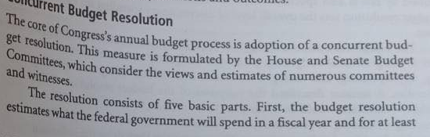

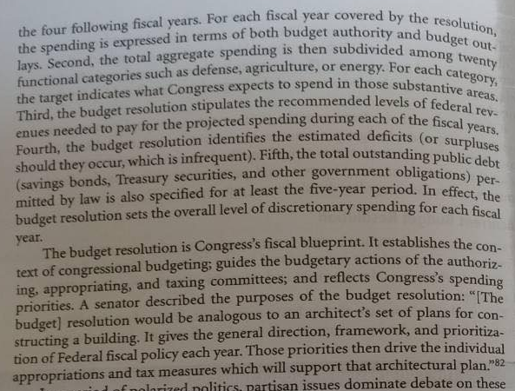

預算決議案是國會的財政藍圖，是國會各授權委員會、撥款委員會、財稅委員會該年度相關後續預算立法行動的指引。但嚴格而論，預算決議案所反映的僅僅是多數黨的政策優先主張，因此院會表決時明顯呈現政黨對決的partisan vote，少數黨自然是盡可能杯葛，因此需要特別的程序控制：在眾議院自然是經由特別規則控制其討論時間及修正案許可範圍，在參議院因有法定討論時間限制，因而少數黨也無法利用冗長發言杯葛。

p.424

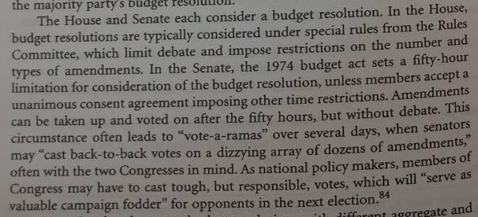

除眾議院依往例均以特別規則規範預算決議案的討論與修正程序外，參議院須受1974年法規定的50 小時討論時間限制，因此參議員無法以冗長發言杯葛預算決議案。

除此以外，當國會兩院分屬兩黨掌控多數時，或者兩院多數黨均與總統不同政黨時，預算決議案最後不太可能兩院意見一致，因此常常未完成該年度預算決議案(某一院根本未通過)，此種情形可參見 <https://crsreports.congress.gov/AppropriationsStatusTable?id=2020>

Select Year: 此部分可選擇2011~2013, 2019,2020

撥款狀態表APPROPRIATIONS STATUS TABLE 點選最右側 BUDGET RESOLUTIONS

預算決議案未完成(兩院一致通過)，並不影響政府運作，只要撥款法通過即可。

p.425 劃一Reconciliation

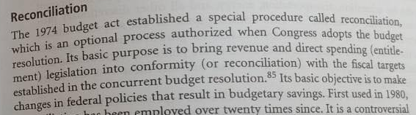

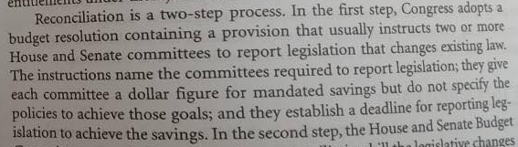

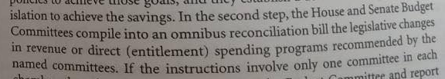

簡而言之，所謂劃一，係指將現行的稅法與直接支出的授權法規定，與年度預算決議案中所訂定的財政目標劃一，具體的說，預算決議案預估的歲入金額不足以支應現行的種種支出，因此訂定了修正現行稅法(加稅)與直接支出的授權法(減支)的額度，據以修法，以達成年度預算決議案所定的財政目標。

pp.425~426

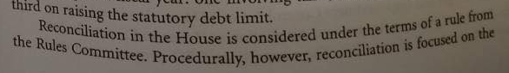

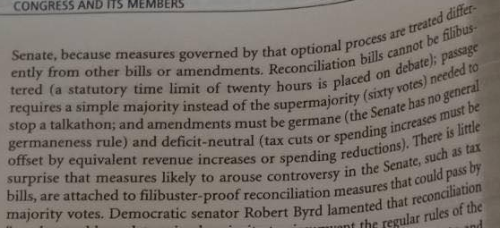

但預算決議案係控制收支的工具，為達成某些抑制財政赤字的目的，預算決議案有時包含了修正現行法---要求某些現行法需與預算決議案所訂財政收支目標一致~所謂「劃一」訓令，因此，後續的預算「劃一」法案在立法過程中享有立法時間限制的保障，法定的討論時間僅限20小時，比預算決議案討論時間更短，參議院中少數黨因而無法以冗長發言杯葛。這表示多數黨在參議院無須60票超級多數即可順利控制立法結果~預算劃一法案。

基於此種原因，多數黨掌握兩院，但參議院欠缺60票超級多數時時，常會以預算劃一程序通過其重要的優先立法。2010年民主黨多數主導的平價醫療法(Obamacare)立法，以及2017年共和黨多數主導的平價醫療法關鍵條款修訂，最後都是利用預算劃一程序完成的。

2008年美國大選與第111屆國會兩院民主黨多數

2008年8月28日在丹佛市(Denver)舉行的民主黨全國代表大會中，總統提名人歐巴馬發表接受提名演說(Acceptance Speech)時，對醫療改革提出了以下主要的承諾：提供人人平價的醫療、既有醫療險保戶降低保費、新保戶可購得與國會議員相同水準的醫療險、禁止保險公司對最需醫療照護的病患因既往病史(pre-existing conditions)歧視(拒保、提高保費、拒絕給付醫療費用等)。歐巴馬對醫療改革的此項宣示，之後在10月15日兩大黨總統候選人辯論時再度重申，並強調將以降低成本的方式使每一家庭每年可減少2,500美元保費。至於降低成本的方法，歐巴馬僅表示將投資資訊科技以縮減人力、擴大預防醫療(preventive care)以控制慢性病的巨額醫療成本。

2008年11月4日美國大選結果，歐巴馬擊敗馬侃(John McCain)，當選總統。國會兩院選舉結果，2006年期中選舉即已取得兩院多數的民主黨，兩院席次均有增加。眾院435席中自110屆國會(2007-2009)的233席擴增至111屆國會(2009-2011)的257席。參院100席中民主黨黨團自選前的51席擴增至選後的58席(包含參與民主黨黨團的獨立派參議員Bernard Sanders, Joseph Lieberman 2人)，共和黨則從選前的49席降至選後的41席，此外明尼蘇達州(Minnesota)則因初步開票結果現任共和黨參議員Norm Coleman領先民主黨候選人Al Franken差距僅216票，仍須等待驗票，因此2009年元月歐巴馬總統就職時民主黨在參議院掌握的議席已經接近60票超級多數的門檻。

即使明尼蘇達州勝選，民主黨在參院也僅有59席，2008年11月歐巴馬及民主黨在國會兩院勝選後，便設法拉攏選情不穩的共和黨國會議員。賓州(Pennsylvania) 共和黨參議員Arlen Specter在2004年賓州參議員共和黨初選時即遭遇黨內競爭對手Pat Toomey的強大壓力，2010年能否連任須視Toomey是否再度參選參議員而定，Arlen Specter遂成為民主黨亟欲爭取的目標。

2009年2月10日，參議院表決政府向產業紓困的「經濟刺激法案(H.R.1 -Economic stimulus bill)」，本案除民主黨黨團58票及共和黨緬因州(Maine)溫和派女議員Olympia Snowe, Susan Collins等2票以外， Specter也投下贊成票。

共和黨人指責白宮與民主黨人以同意Specter所提100億美元國家衛生研究院(National Institutes of Health)經費修正案作手段向他「買票(bought your vote)」，保守派談話性節目主持人Laura Ingraham訪問他時並嘲諷Specter「身為共和黨卻反對其他共和黨人時，在白宮吃吃喝喝真好(Is it nice to be wined and dined at the White House, and you're treated pretty well when you're a Republican bucking other Republicans?)」。{參見後附影片 20090211 Specter responds to angry GOP }

2009年4月28日，Specter宣布他將投入2010年賓州民主黨參議員初選，正式成為參院民主黨的一員。(參見後附影片 20090211 Specter responds to angry GOP、20090428 Specter 'at odds' with GOP)

2009年明尼蘇達州驗票結果民主黨Al Franken反而以312票勝過共和黨Norm Coleman，選舉訴訟持續至2009年6月，明尼蘇達州最高法院判決Al Franken勝選，Norm Coleman放棄繼續(向聯邦最高法院)上訴，7月6日Franken宣誓就職，於是民主黨在參議院的60席超級多數終於形成。

一致性政府與醫療改革議題設定

2009年2月24日歐巴馬首次在國會兩院聯席會議發表演說，在醫療改革問題上再次強調「應提供人人優質、平價的醫療(that we must have quality, affordable health care for every American)」，並宣示將於下週邀集醫療及保險相關產業及兩黨人士研商醫療改革種種不同的意見與想法。 3月2日歐巴馬宣布將由堪薩斯州(Kansas)州長Kathleen Sebelius擔任衛生部長(Secretary of Health and Human Services)、前柯林頓(Bill Clinton)總統任內官員Nancy-Ann DeParle為「白宮醫改沙皇(White House Health care czar)」(DeParle的正式職銜為新設的「白宮醫療改革辦公室主任(director of the White House Office of Health Reform)」)。

[ 所謂「白宮沙皇(White House czar)」係美國媒體創造的名詞，指總統所任命的高層顧問，其各自的正式職銜不一，但大多數均係由總統直接任命，無須參議院同意。由於聯邦政府的規模與角色日益龐雜，同一問題常牽涉多部門管轄，此類「沙皇」的角色即在針對某一特定問題進行跨部門的政策整合。由於此類幕僚係直接向總統報告，實質影響力極大，所以被媒體稱為「沙皇Czar」。]

3月5日歐巴馬召集了醫師、病患、醫院主管、保險業者、藥商，以及國會兩黨議員等各方人士代表約120人，在白宮舉行美國醫療制度改革論壇(White House Forum on Health Reform)。論壇由歐巴馬親自主持，並分為五組，各組均就醫療改革的重要、醫療成本高漲、醫療保險範圍擴大及品質、醫療改革經費來源等五項提綱進行討論。論壇在形式上係聽取各方對醫改的意見以凝聚共識，實質上當時上任不久的歐巴馬總統，希望能透過此種論壇形式，以其2008年勝選的聲望與大眾對醫療費用高漲不滿的情緒，創造其普及化醫療保險(universal coverage)的改革氣勢。

鑑於1990年代柯林頓總統時期第一夫人希拉蕊(Hillary Clinton)主導的醫療改革，當時白宮雖提出了具體的醫改提案，卻未能將國會議員的種種意見納入，最後無疾而終的教訓，2009年白宮雖舉辦了醫改論壇，卻未提出具體的醫改提案，參與此次白宮論壇的參議院財政委員會主席Max Baucus，當時即向媒體透露，未來他將扮演撰擬醫改立法提案的主要角色。4月8日歐巴馬總統簽署13507號行政命令，白宮醫改辦公室正式成立。4月28日賓州參議員Arlen Specter投入民主黨的同一天，參議院以65比31通過了衛生部長Sebelius的提名案，Sebelius隨即宣誓就職。

[ 歐巴馬總統於2013年12月20日宣布提名Max Baucus擔任駐中國大使，提名案2014年2月6日獲參議院96比0同意，Baucus為第11任美國駐中國大使，2017年元月新任共和黨籍總統川普(Donald Trump)通知所有歐巴馬任命的駐外大使必須在元月20日新總統就職日卸任。]

兩院委員會醫改政策規劃

2009年6月17日，參議院衛生、教育、勞工、退休金委員會(Senate Health, Education, Labor and Pension Committee ~簡稱HELP committee)開始討論醫療改革法案(S.1679 Affordable Health Choices Act)，615頁厚的醫改法案以衛生委員會主席甘迺迪之名直接提交委員會討論(所謂「主席草案 Chairman’s mark」)，由於甘迺迪年初腦瘤暈厥後體力不佳，自6月17日至7月15日一個月間，醫改案討論係由代主席康州(Connecticut)參議員Christopher Dodd主持。甘迺迪版醫改案中即包括提供政府公營醫療保險選項、強制個人應購醫療保險及雇主應提供員工保險等為共和黨反對的主要爭議，關鍵問題仍在於擴大當時醫療保險制度涵蓋範圍時如何控制醫療成本不上漲 ~因為這會間接導致保費上漲。7月15日衛生委員會以全體民主黨委員13人贊成、全體共和黨委員10人反對的票數通過醫改提案。) 一個月之後甘迺迪在8月25日病逝，衛生委員會主席在9月9日由Iowa州參議員Tom Harkin接任，至於S.1679醫改案，最後由新任主席Harkin在9月17日正式提報參院，由於本案為甘迺迪任內的產物，Harkin僅倉促代為完成提案手續，並無書面委員會報告提出。

7月14日參院衛生委員會通過醫改案的前一天，眾議院民主黨人以全院最年長的John D. Dingell 具名提出眾院版醫改法案(H.R.3200 America's Affordable Health Choices Act of 2009)，以紀念醫療保險立法最早的提案者─其父John D. Dingell Sr. 在眾院1943年的提案。Dingell的醫改案隨即分為三部分，分別交付能源與商業(Energy and Commerce)、財稅(Ways and Means)、教育及勞工(Education and Labor)三委員會審查。付委四日後(7月17日)財稅、教育及勞工兩委員會分別以23比18、26比22通過委員會報告，但其中兩委員會民主黨委員各自均有3人投反對票，7月31日能源與商業委員會亦以31比28通過報告，但同樣有民主黨委員5人投反對票。

Committee on Energy and Commerce roll call vote

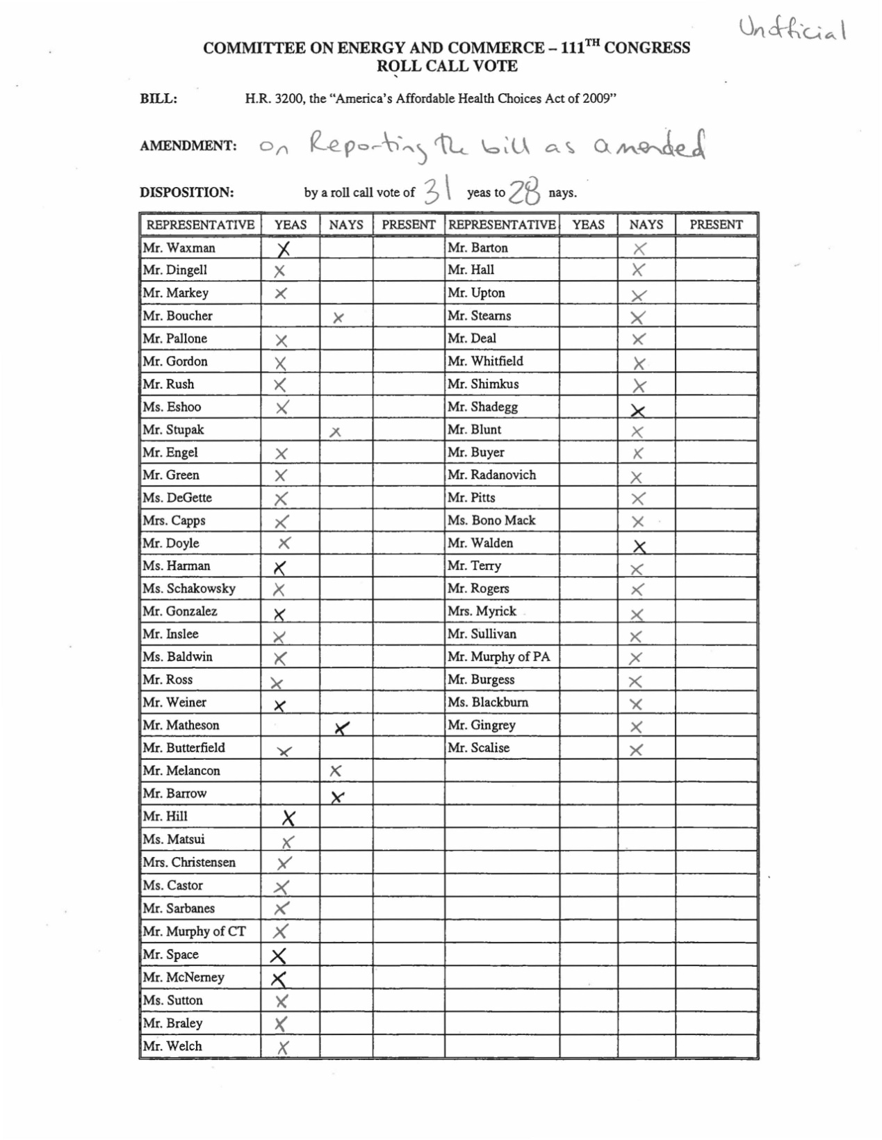

Committee on Education and Labor roll call vote

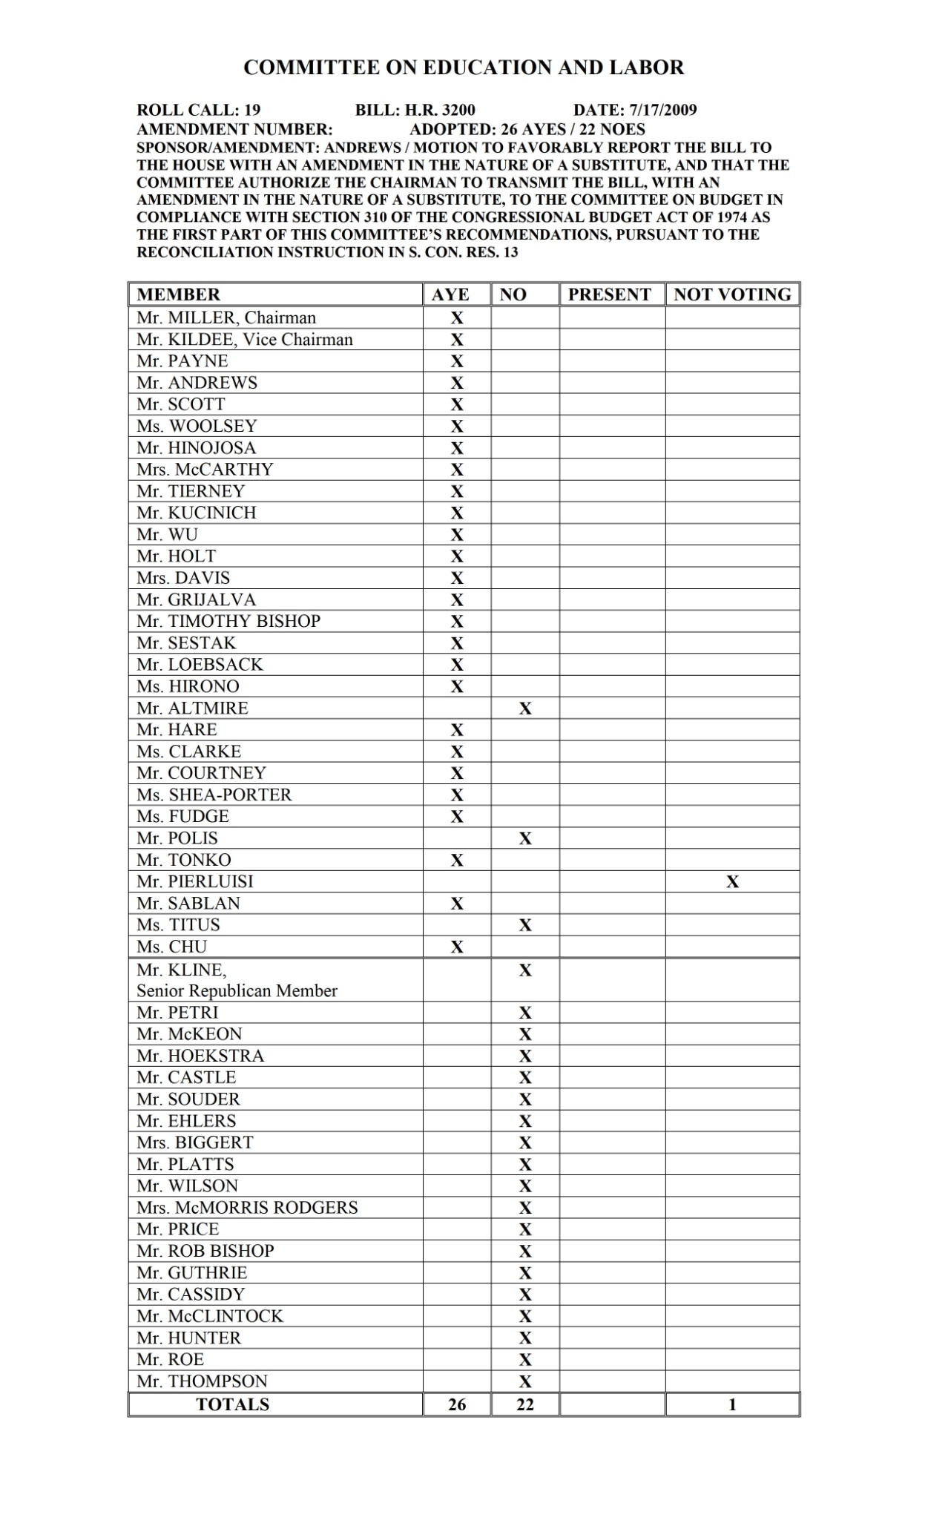

Committee on Ways and Means roll call vote

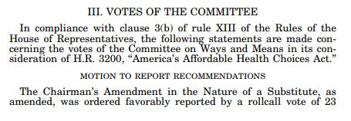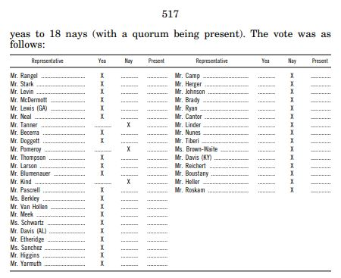

眾議院民主黨在2006年期中選舉時，於27個保守派傾向的選區擊敗共和黨，2008年大選又另外贏得26個保守派選區的議席，民主黨黨團內部這些新增的保守派選區議員，勢必無法完全支持黨團自由派主流的醫改案，此種黨內保守派與主流自由派不同調的情形，不但在眾議院三個委員會審查階段出現，之後也直接衝撞到醫改案在眾院院會的表決。

Obamacare 預算決議案

2009年4月29日參眾兩院通過預算共同決議案(S.CON.RES.13)兩院最後版本協商報告(Conference report)，其中規定兩院共計五個委員會(即醫改法案的五個委員會)應各自提出能夠降低赤字10億美元的相關現行法修正提案，並規定眾院教育與勞工委員會另外提出降低赤字10億美元「投資教育(Investing in Education)」的修法提案，依字面意義而言，五個委員會合計應提出降低40億美元赤字的修法提案(參院兩個委員會如有提案最後應與眾院協商後併案)。事實上降低赤字僅為表面的手段，主要目的在預防參議院最後如未能掌握60票超級多數時，可以藉此預算劃一程序完成醫改立法。

S.CON.RES.13

MAJOR ACTIONS:

3/27/2009 Introduced in Senate

3/27/2009 Committee on the Budget. Original measure reported to Senate by Senator Conrad under authority of the order of the Senate of

03/26/2009. Without written report.

4/2/2009 Passed/agreed to in Senate: Resolution agreed to in Senate with amendments by Yea-Nay Vote. 55 - 43. Record Vote Number: 154.

4/22/2009 Passed/agreed to in House: On agreeing to the resolution Agreed to without objection.

4/27/2009 Conference report H. Rept. 111-89 filed.

4/29/2009 Conference report agreed to in House: On agreeing to the conference report Agreed to by the Yeas and Nays: 233 - 193 (Roll no. 216).

4/29/2009 Conference report agreed to in Senate: Senate agreed to conference report by Yea-Nay Vote. 53 - 43. Record Vote Number: 173.

Setting forth the congressional budget for the United States Government for fiscal year 2010, revising the appropriate budgetary levels for fiscal year 2009, and setting forth the appropriate... (Enrolled Bill [Final as Passed Both House and Senate] - ENR)

以下是S.CON.RES.13中劃一訓令部分

TITLE II--RECONCILIATION

SEC. 201. RECONCILIATION IN THE SENATE.

(a) Committee on Finance- The Senate Committee on Finance shall report changes in laws within its jurisdiction to reduce the deficit by $1,000,000,000 for the period of fiscal years 2009 through 2014.

(b) Committee on Health, Education, Labor, and Pensions- The Senate Committee on Health, Education, Labor, and Pensions shall report changes in laws within its jurisdiction to reduce the deficit by $1,000,000,000 for the period of fiscal years 2009 through 2014.

(c) Submissions- In the Senate, not later than October 15, 2009, the Senate committees named in subsections (a) and (b) shall submit their recommendations to the Senate Committee on the Budget. Upon receiving all such recommendations, the Senate Committee on the Budget shall report to the Senate a reconciliation bill carrying out all such recommendations without any substantive revision.

SEC. 202. RECONCILIATION IN THE HOUSE.

(a) Health Care Reform-

(1) The House Committee on Energy and Commerce shall report changes in laws to reduce the deficit by $1,000,000,000 for the period of fiscal years 2009 through 2014.

(2) The House Committee on Ways and Means shall report changes in laws to reduce the deficit by $1,000,000,000 for the period of fiscal years 2009 through 2014.

(3) The House Committee on Education and Labor shall report changes in laws to reduce the deficit by $1,000,000,000 for the period of fiscal years 2009 through 2014.

(b) Investing in Education- The House Committee on Education and Labor shall report changes in laws to reduce the deficit by $1,000,000,000 for the period of fiscal years 2009 through 2014.

(c) Submissions- In the House, not later than October 15, 2009, the House committees named in subsections (a) and (b) shall submit their recommendations to the House Committee on the Budget. Upon receiving all such recommendations, the House Committee on the Budget shall report to the House a reconciliation bill carrying out all such changes without any substantive revision.

有關參議員Arlen Specter轉換政黨的新聞片如下

12-11a 20090211 Specter responds to angry GOP * 5:05

20090211 am.intv.specter.cnn_576x324_dl.flv

( CNN's John Roberts speaks to Sen. Arlen Specter about his support for President Obama's stimulus plan.

• Stimulus deal 'possible' by Wednesday, lawmaker says )

12-11b 20090428 Sen. Specter to switch * 3:01

20090428 bash.specter.democrat.cnn_576x324_dl.flv

( Sen. Arlen Specter intends to switch parties, which would add to the Democratic majority in the Senate. CNN's Dana Bash reports. )

12-11c 20090428 Specter 'at odds' with GOP * 3:40

20090428 sot.specter.at.odds.cnn_576x324_dl.flv

( Sen. Arlen Specter says he has found himself to be "at odds with the philosophy of the Republican party." )

有關參議員Al Franken驗票後贏得民主黨第60席的新聞片如下

12-11d 20081105 Franken wants recount 1:20 本片暫無字幕檔

20081105 bts.franken.recount.kare_576x324_dl.flv

('Al Franken says that with his Senate race too close to call, he will seek a recount.')

12-11e 20081111 Nasty race in Minnesota * 2:25

20081111 tsr.todd.mn.recount.cnn_576x324_dl.flv

( Minnesota's contentious and often nasty Senate race is heading to a recout. CNN's Brian Todd reports. )

12-11f 20090701 Franken wins in Minnesota 1:32 本片暫無字幕檔 20090701 endo.franken.win.cnn_576x324_dl.flv

( Al Franken wins Minnesota's U.S. Senate seat. CNN's Sandra Endo has the story.

• Commentary: Franken victory is not funny )

12-11g 20090706 The Franken factor * 2:27

20090706 am.acosta.franken.factor.cnn_576x324_dl.flv

( Senator-elect Al Franken could give Democrats a filibuster-proof majority. CNN's Jim Acosta reports. )

以下是字幕檔

12-11a 20090211 Specter responds to angry GOP 5:05

20090211 am.intv.specter.cnn_576x324_dl.flv

JOHN ROBERTS, CNN ANCHOR:

ROBERTS: After nine hours of closed-door meetings late last night, law makers on Capitol Hill will keep negotiating the stimulus bill today. They're trying to reconcile the House and Senate versions. The bill only cleared the senate because of the support of three Republicans who now face a rather, shall we say, angry Republican Party?  
  
One of those three is Senator Arlen Specter of Pennsylvania. He joins us now from Capitol Hill. Senator, it's good to see you this morning. You said that you lost a lot of political skin supporting this stimulus bill, so why did you support it?  
  
SEN. ARLEN SPECTER (R), PENNSYLVANIA: I supported it because of the urgent necessity in the public interest. You have a very severe economy downturn of more than three million jobs lost, millions of people being foreclosed from their houses, and it seemed to me that we had to take action.  
  
And the economists tell us that if we didn't act, we could be right on the edge of a depression like 1929. And I think in that context, you have to put your own political interests aside and do what's required for the country.  
  
ROBERTS: On the subject of political interest, what do you say about Republican complaints that the White House and Democrats in Congress bought your vote by approving your amendment for $10 billion in funding for the National Institutes of Health?  
  
SPECTER: Well, I say it's ridiculous. The National Institutes of Health stand on their own. That money will create some 70,000 jobs. And in an era when medical costs are going up what better ways there are to cut medical costs than prevention. You're looking here at a $780 billion bill.  
  
To suggest that I would make a deal for $10 billion or any one item, is ridiculous. You ought to hear the clamor back home in Pennsylvania. I had a very tough primary fight last time I was out, and I don't make deals.  
ROBERTS: Yes, I mean, there was rather contentious moment the other when conservative talk-show host Laura Ingraham accused you of being wined and dined by the White House.  
  
Let me just play that moment and get you to respond to it.  
  
(BEGIN AUDIO CLIP)  
  
LAURA INGRAHAM, HOST, "THE LAURA INGRAHAM SHOW": Is it nice to be wined and dined at the White House, and you're treated pretty well when you're a Republican bucking other Republicans?  
  
SPECTER: Now, let's get off it, Laura. I'm not drinking any wine at the White House and I don't dine at the White House. If the president wants to talk to me, I talk to him and I make my own independent judgment.  
  
(END AUDIO CLIP)  
  
ROBERTS: Senator Specter, you really took exception to her charge.  
  
SPECTER: Well, it's preposterous. You're dealing here with a gigantic sum of money. You're dealing with the economy on the edge of the ledge, perhaps going to a depression like 1929. And to make a suggestion that I would be influenced by being wined and dined at the White House is just absurd.  
  
Listen, in my position, I'm prepared to take whatever bricks and bats come, whatever criticism there is. But don't expect me to take an absurd statement like that lying down. And I responded to her very forcefully.  
  
Listen, Laura Ingraham's a tough cross-examiner. I know one when I see one, but I didn't lose any skin in that interview. I've lost some skin otherwise, not with Laura Ingraham. At least not on Monday.  
  
ROBERTS: Talking about bricks and bats, Senator, I think you're going to be facing more than a few in 2010. You're going to run for reelection. You had a tough primary in 2004. This one's going to be even tougher.  
  
You got the powerful national Republican trust threatening to pour millions of dollars into a challenger, whatever it takes to defeat you.  
  
SPECTER: Well, I understand the peril, but I didn't run for the United States senate to further my own political interests. I think when you have a decision like the one that we're facing now, there's only one way to respond, and that's to respond with action.  
  
And if somebody else in the Republican party had stepped up to do the negotiations and handle it, I would have been glad to step aside. But when they call the ballot and you face the situation that there could be an economic catastrophe, the only responsible thing to do is to support the package.  
  
And bear in mind, the Republican moderates' program got $110 billion cut. We've got the backing of the United States Chamber of Commerce, which is a very conservative, Republican organization. They know the economy better than perhaps anybody, because they're in touch with so many thousands of businesses. And they say the economy requires it. And that it's a good plan, not a perfect plan, but a good plan. And I'll take my chances.  
  
ROBERTS: Well, certainly, Senator, nobody could ever accuse you of not being up for a fight. It's good to talk to you this morning. Thank you for joining us.  
  
SPECTER: Always glad to do it. Thank you John.

<https://transcripts.cnn.com/show/ltm/date/2009-02-11/segment/03>

************************

12-11b 20090428 Sen. Specter to switch 3:01

20090428 bash.specter.democrat.cnn_576x324_dl.flv

DANA BASH, CNN SENIOR CONGRESSIONAL CORRESPONDENT: That's right. We do have big news here on Capitol Hill. Senator Arlen Specter, now a Republican from Pennsylvania, has announced that he is going to switch parties. He is going to become a Democrat. This is seismic political news here in Washington for so many reasons.  
  
First and foremost, Arlen Specter -- actually, this has been rumored all morning, but he did just confirm it. He put up a statement on a political Web site in his home state of Pennsylvania basically saying that his Republican Party, he no longer feels that it defines who he is. And he has said he has taken issue one at a time over various issues, but basically, bottom line is he says he doesn't feel comfortable as a Republican right now, so he is going to switch to become a Democrat.  
  
So, it's big news. There are a lot of political reasons why he is doing this, Tony.  
  
First and foremost, he's going to have or would have had a huge Republican primary run in the state of Pennsylvania. Pat Toomey, who is a conservative, was already running against him, already doing quite well in the polls. So that is another reason for this.  
  
But it is a huge, huge breaking news story that's happening right now here on the Hill.  
  
HARRIS: Dana, Dana, Dana, balance of power in the Senate, please.  
  
BASH: Right. That's the next question. Thank you for asking that, because there's so many different facets of this story, and that is another one.  
  
Right now, Tony, we have 58 Democratic senators. If Norm Coleman loses and the Democrat from the state of Minnesota actually wins, that would be 59 seats. We're still waiting for that to be formalized, but we do think that is going to happen.  
  
Arlen Specter would give Democrats the 60th seat. What does that mean? We talk all the time here about how Democrats have a big majority in the House, a big majority in the Senate, but not a filibuster-proof majority. Sixty votes would give Democrats that majority. That is another reason why this is such an enormous story for Democrats, an enormous story when it comes to the future of the Obama agenda here on Capitol Hill.  
  
HARRIS: Exactly. Well, and you led me right to the next question.  
  
With a filibuster-proof majority, what would Republicans be able to do effectively to block anything in that agenda?  
  
BASH: Not very much. But I think the one thing that I do have to say, though, is that it gives Democrats a filibuster-proof majority on paper in terms of the hard numbers. But what we have learned is that you have conservative Democrats, so to speak, who already don't necessarily agree with their majority party, who, depending on the issue, have not voted with them.  
And Arlen Specter, as a new conservative Democrat -- because there's no question as a former Republican, that's what he would be on many issues -- he would not necessarily be a given in terms of a vote for the Democrats depending on the issue that is before them.  
  
However, having said that, it certainly gives to the gist of the votes on any given vote going into any big issue: health care -- you know, even the nomination of people for the Obama cabinet, or for underneath the key agencies, it gives Democrats some breathing room that they simply did not have until now.

<https://transcripts.cnn.com/show/cnr/date/2009-04-28/segment/04>

***********************

12-11c 20090428 Specter 'at odds' with GOP * 3:40

20090428 sot.specter.at.odds.cnn_576x324_dl.flv

SEN. ARLEN SPECTER (D), PENNSYLVANIA: The Republican Party has moved farther and farther to the right. I have found myself increasingly at odds with the Republican philosophy and more in line with the philosophy of the Democratic Party.  
  
When the stimulus package came up for a vote, I felt that it was indispensable to vote aye in order to avoid the possibility of a 1929- type depression. In the course of the last several months since the stimulus vote, I have traveled the state, surveyed the sentiments of the Republican Party in Pennsylvania, done public opinion polls, observed other public opinion polls, and have found that the prospects for winning the Republican primary are bleak.  
  
Now, I am not prepared to have my 29-year record in the United States Senate decided by the Pennsylvania Republican primary electorate. Not prepared to have that record decided by that jury, the Pennsylvania Republican primary electorate.  
  
But I'm prepared to take on all comers, all comers in a general election. And therefore, I've decided to be a candidate for reelection in 2010 in the Democratic primary.  
  
This is a painful decision. I know that I'm disappointing many of my friends and colleagues. Frankly, I've been disappointed by some of the responses, so the disappointment runs in both directions.  
  
I do not undertake this because of the absence of other challenging or interesting things that I could undertake outside of the Senate, but I do this because there are many projects that I want to move ahead for Pennsylvania with my continuing seniority in the United States Senate, and one of the key interests I have is medical research, and want to continue my work in that field. I think it is fair and accurate to say that the increases in funding for the National Institutes of Health, which I have spearheaded, have saved or prolonged many lives, including my own.  
  
One item that I want to emphasize that I will not be changing my own personal independence or my own approach to individual issues. I will not be an automatic 60th vote.  
  
I note that some of the news stories, since my statement was released this morning, are taking a look at the 60th vote. I will not be an automatic 60th vote.

<https://transcripts.cnn.com/show/cnr/date/2009-04-28/segment/06>

****************************

12-11e 20081111 Nasty race in Minnesota 2:25 *

20081111 tsr.todd.mn.recount.cnn_576x324_dl.flv

BRIAN TODD, CNN CORRESPONDENT:

TODD: They've taken Minnesota's reputation for civil politics and dumped it on its ear. Now the competitive senate race between incumbent Republican Norm Coleman and comedian turned candidate Al Franken is headed toward extra innings, despite the fact that Coleman's declared victory twice.  
  
SEN. NORM COLEMAN (R), MINNESOTA: Yesterday the voters spoke. We prevailed.  
  
TODD: That was November 5th when Coleman's lead was 725 votes. The latest tally from the Minnesota secretary of state's office has Coleman ahead by just 206 votes and we're headed to a recount that'll begin next week.  
  
PROF. LARRY JACOBS, UNIV. OF MINNESOTA: It is quite possible that the Minnesota senate race will not be settled by the beginning of the 2009 new session in congress.  
  
TODD: Nearly 3 million votes cast. All on paper ballots. Now have to be examined by hand. They include about 25,000 ballots where votes for president were cast, but not votes for senate. Observers say most of those votes were in Democratic counties with many first- time voters, so the markings will have to be checked very carefully. It adds to the intrigue of a race characterized by both candidates calling each other misleading and this add from Coleman's side showing Franken's less than senatorial moments.  
  
AL FRANKEN: You are wrong and you have to apologize, ma'am. How [ bleep ] shameless these people are. These people are so [ bleep ] shameless.  
  
TODD: A spot that brought so much backlash, Coleman had to promise a more positive campaign. Why is this race so personal? One analyst says it harkens back to when Coleman won the seat held by the late Democratic Senator Paul Wellstone.  
  
JACOBS: This is almost a blood vendetta. Al Franken was good friends with Wellstone who died in a plane crash only about 10 days before Election Day back in 2002. Al Franken has dropped his career as a comedian to move back to Minnesota to run this race.  
  
(END VIDEOTAPE)  
  
TODD: Like any recount, battle lines are already being drawn. In Minnesota there are questions about possible fraud from Coleman's side which Franken's people deny and lawyers for both sides gearing up for this recount. It could get nasty.  
  
BLITZER: As you know there's a Republican governor but the state lately has been pretty Democratic.  
  
TODD: That's right. It's playing into this. The secretary of state himself is a Democrat. It's a heavily Democratic state. The Coleman people are ready to pounce if they see anything hinting of partisanship. The secretary of state himself told me no way is it going to creep into that. Minnesota actually has a good reputation for having clean recounts in these things. They've got three other recounts going on now for statewide races.

<https://transcripts.cnn.com/show/sitroom/date/2008-11-11/segment/02>

*******************************

12-11g 20090706 The Franken factor 2:27

20090706 am.acosta.franken.factor.cnn_576x324_dl.flv

JIM ACOSTA, CNN CORRESPONDENT: That's right. Although that's not what the Democrats hope. They definitely hope he will be that 60th vote. And Al Franken will be on the Hill today. It's not clear just yet when he'll be sworn in as a United States senator, but Al Franken's arrival in Washington already has Democrats seeing 60 in the Senate, where Republicans may have lost their last legislative weapon, the filibuster.  
  
(BEGIN VIDEOTAPE)  
  
UNIDENTIFIED FEMALE: Our next senator, Al Franken.  
  
ACOSTA (voice-over): Democrats are counting the seconds until live from Washington, it's Al Franken.  
  
AL FRANKEN (D), MINNESOTA SENATOR-ELECT: Thank you.  
  
ACOSTA: The former "Saturday Night Live" comedian turned politician is about to hand his party 60 seats in the Senate, if you include the two independents now aligned with Democrats. Franken, a Harvard graduate who can do the math, is downplaying expectations.  
  
FRANKEN: The way I see it, I'm not going to Washington to be the 60th Democratic senator, I'm going to Washington to be the second senator from the state of Minnesota.  
  
ACOSTA: But that's not how others in the Senate see it.  
  
SEN. BERNIE SANDERS (I), VERMONT: What I think is, it should be a game changer.  
  
ACOSTA: It takes 60 senators to kill a filibuster. So Vermont's independent Senator Bernie Sanders is challenging any wavering colleagues within the new Democratic supermajority to stick together, and block any filibuster attempts aimed at health care.

SANDERS: At the very least what we should be doing united is saying to the Republicans, you cannot filibuster a strong health care bill to death. If it turns out there are only 52, 53, 54 people who vote for final passage, that's the way it is. That's the majority.  
  
ACOSTA: But in that deck of 60, there are a few wild cards. Take Connecticut's Joe Lieberman, who told the "New Haven Independent" he is not sold on a Democratic health care proposal that will give the public the option of joining a government plan.  
  
[ SEN. JOE LIEBERMAN (I) CONNECTICUT: I'm skeptical of it, both in substance and in the politics. By the politics, I mean, I think we're not going to get the votes to pass the overall bill and it becomes conditional.]  
  
ACOSTA: Other democratic wild cards from red states in the west and south are also in the mix, which may explain why the White House knows 60 is not necessarily a magic number.  
  
ROBERT GIBBS, WHITE HOUSE PRESS SECRETARY: We don't get everybody from every party on every vote. That includes the democratic party.  
  
(END VIDEOTAPE)  
  
ACOSTA: Not to mention the fact that two prominent Democrats, Ted Kennedy and Robert Byrd, have been battling illnesses, and it's still unclear whether recent Republican turned Democrat Arlen Specter will even be a reliable vote. Given all that, it may take some magic for the Democrats to get to 60, but Al Franken is good enough. He is smart enough, and doggone it, Kiran, he is almost a United States senator.

<https://transcripts.cnn.com/show/ltm/date/2009-07-06/segment/03>